Aluminum plate covered with plexiglass
Screwed onto plywood face on a 4x4 post.
Station 1 thru 7 will have this picture as reference and each station with its own QR code.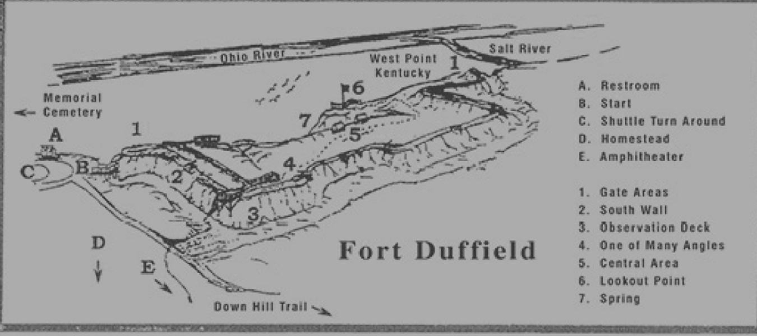

Additional Sign

Fort Duffield
Fort Duffield Park and Historic Site is a 175-acre resource in North Hardin County, Kentucky. Once part of the Fort Knox Installation, the land was given to the City of West Point in 1978 as part of the National Park Service Lands to Parks Program to be used for public recreation. The historic site, Kentucky's largest and best-preserved Civil War earthen fortification, sits within the park high atop historic Pearman Hill, 300 feet above the City of West Point. The fort is a Kentucky Landmark and on the Civil War Discovery Trail.

4x4 post

